**Directions:**

Read the description of the online shopping store provided, then respond to the prompts for Phases I and II. Use this document to enter your responses. Save all responses in this document as a single PDF titled “Last Name_First Name_Online Shopping Store Project_Submission”.

**Phase I**

Develop a scenario for each quality factor based on the online shopping example in the Project Description and explain how to test that quality factor for the client-server web application in the space provided. *You may use additional pages as needed to answer this question.*

**Quality Factor: Time Behavior**

1. Source of Stimulus: End user (customer)
2. Stimulus: The customer queries a t-shirt from the clothing section
3. Environment: Normal operation
4. Artifact: Program code (query portion)
5. Response: Query is processed
6. Response Measure: Response to customer’s query should be available within 20-30 seconds

How to test time behavior:

[Explain how to test this quality factor in this space]

To test the time behavior, I would try to make several different queries for clothing items and record the response time it takes to make the queries available and hopefully it will satisfy the 20-30 second response measure.

**Quality Factor: Confidentiality**

1. Source of Stimulus: Unauthorized user
2. Stimulus: User tries to change their stored address
3. Environment: Normal operation
4. Artifact: Data within user’s stored information
5. Response: Block access to user’s data
6. Response Measure: Probability of preventing unauthorized access to a user’s personal information

How to test confidentiality:

[Explain how to test this quality factor in this space]

To test the confidentiality, I would have an unauthorized user try to access personal information about a customer like their address and try to modify it. Since the user is unauthorized the system should block the user from accessing the personal information about a customer and prevent an attack from happening.

**Quality Factor: Recoverability**

1. Source of Stimulus: End user (customer)
2. Stimulus: The customer selected virtual fitting room option and it crashed
3. Environment: Normal operation that has crashed
4. Artifact: Virtual fitting room process
5. Response: System detects crash and informs operator and make virtual fitting room unavailable until it has recovered
6. Response Measure: Recover as fast as possible within 10 minutes of downtime

How to test recoverability:

[Explain how to test this quality factor in this space]

To test the recoverability, I would place some bugs in the code so that when trying to access the virtual fitting room functionality the system would crash and then the system would inform the operator and make the virtual fitting room unavailable and hopefully it will recover within the 10 minutes of downtime.

**Phase II**

Draw each diagram according to the online shopping store situation described in the project description. Take a clear screenshot of each diagram and paste it in the corresponding space provided. *You may add additional pages as needed.*

**System Diagram:**

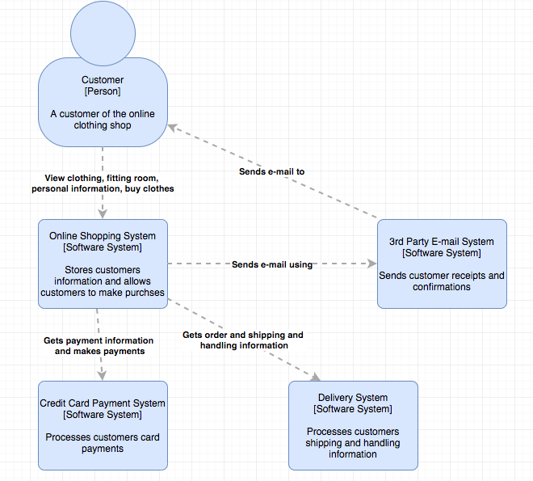

**Container Diagram:**

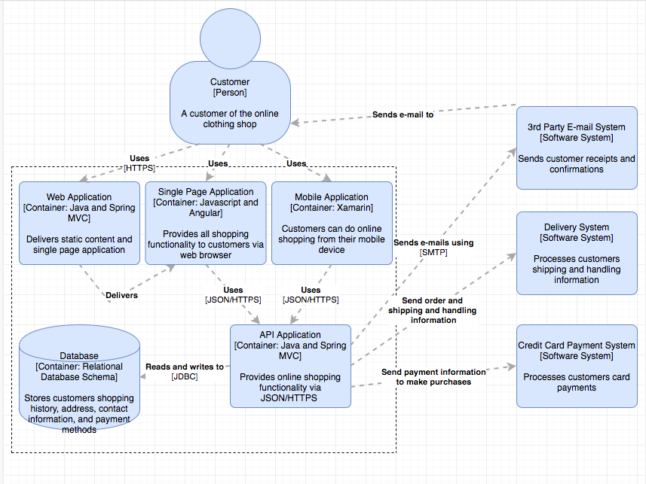

**Deployment Diagram:**

